SMALL BUSINESS CRM
@CREATIVITY THINK (9483175986/7019689991)

ABSTRACT:
Small Business CRM is a web-based application designed to help freelancers, stores, and consultancies manage customer relationships efficiently. The platform allows users to maintain a structured customer database, track contact history, log emails, follow sales funnels, and generate analytics dashboards. Administrators can add or remove customers, oversee the sales pipeline, and generate comprehensive reports. Developed using Django and Django Rest Framework for backend services, and React with redux and chart.js for frontend visualization, the system ensures streamlined customer management, enhanced sales tracking, and actionable business insights..

INTRODUCTION OF THE PROJECT:
Small businesses often struggle with maintaining organized customer information and tracking interactions across multiple platforms. Manual tracking of contacts, emails, and sales activities can lead to lost opportunities and inefficient workflows. Small Business CRM addresses these challenges by providing a centralized system for managing customer data, contact history, and sales processes. The application offers dashboards with visual analytics, allowing both users and administrators to make informed decisions, improve follow-ups, and optimize sales performance..

PROJECT OBJECTIVES:

• Provide a centralized platform for managing customer information
• Track customer contacts, emails, and interaction history
• Support sales funnel monitoring for lead management
• Enable administrators to add, update, or delete customer records
• Generate dashboards with visual analytics for better decision-making
• Ensure secure and structured storage of customer data
• Reduce manual errors and improve operational efficiency
• Support reporting and actionable insights for small businesses

PROBLEM OF THE STATEMENT:
Small businesses often rely on spreadsheets, emails, or unstructured tools to manage customer interactions. This approach leads to inefficiency, missed follow-ups, scattered data, and lack of insights into the sales pipeline. Administrators find it difficult to generate reports or track performance effectively. Small Business CRM solves these problems by providing a unified, structured platform that automates contact tracking, centralizes customer data, and offers analytics-driven insights to improve customer relationships and sales efficiency..

MOTIVATION OF THE PROJECT:
• To streamline customer relationship management for small businesses
• To provide accurate tracking of interactions and contact history
• To visualize sales funnels and improve lead conversion
• To generate actionable analytics for business decisions
• To enable administrators to manage customer data efficiently
• To reduce manual processes and errors in sales tracking
• To improve productivity and client satisfaction

BLOCK DAIGRAM OF PROJECT:

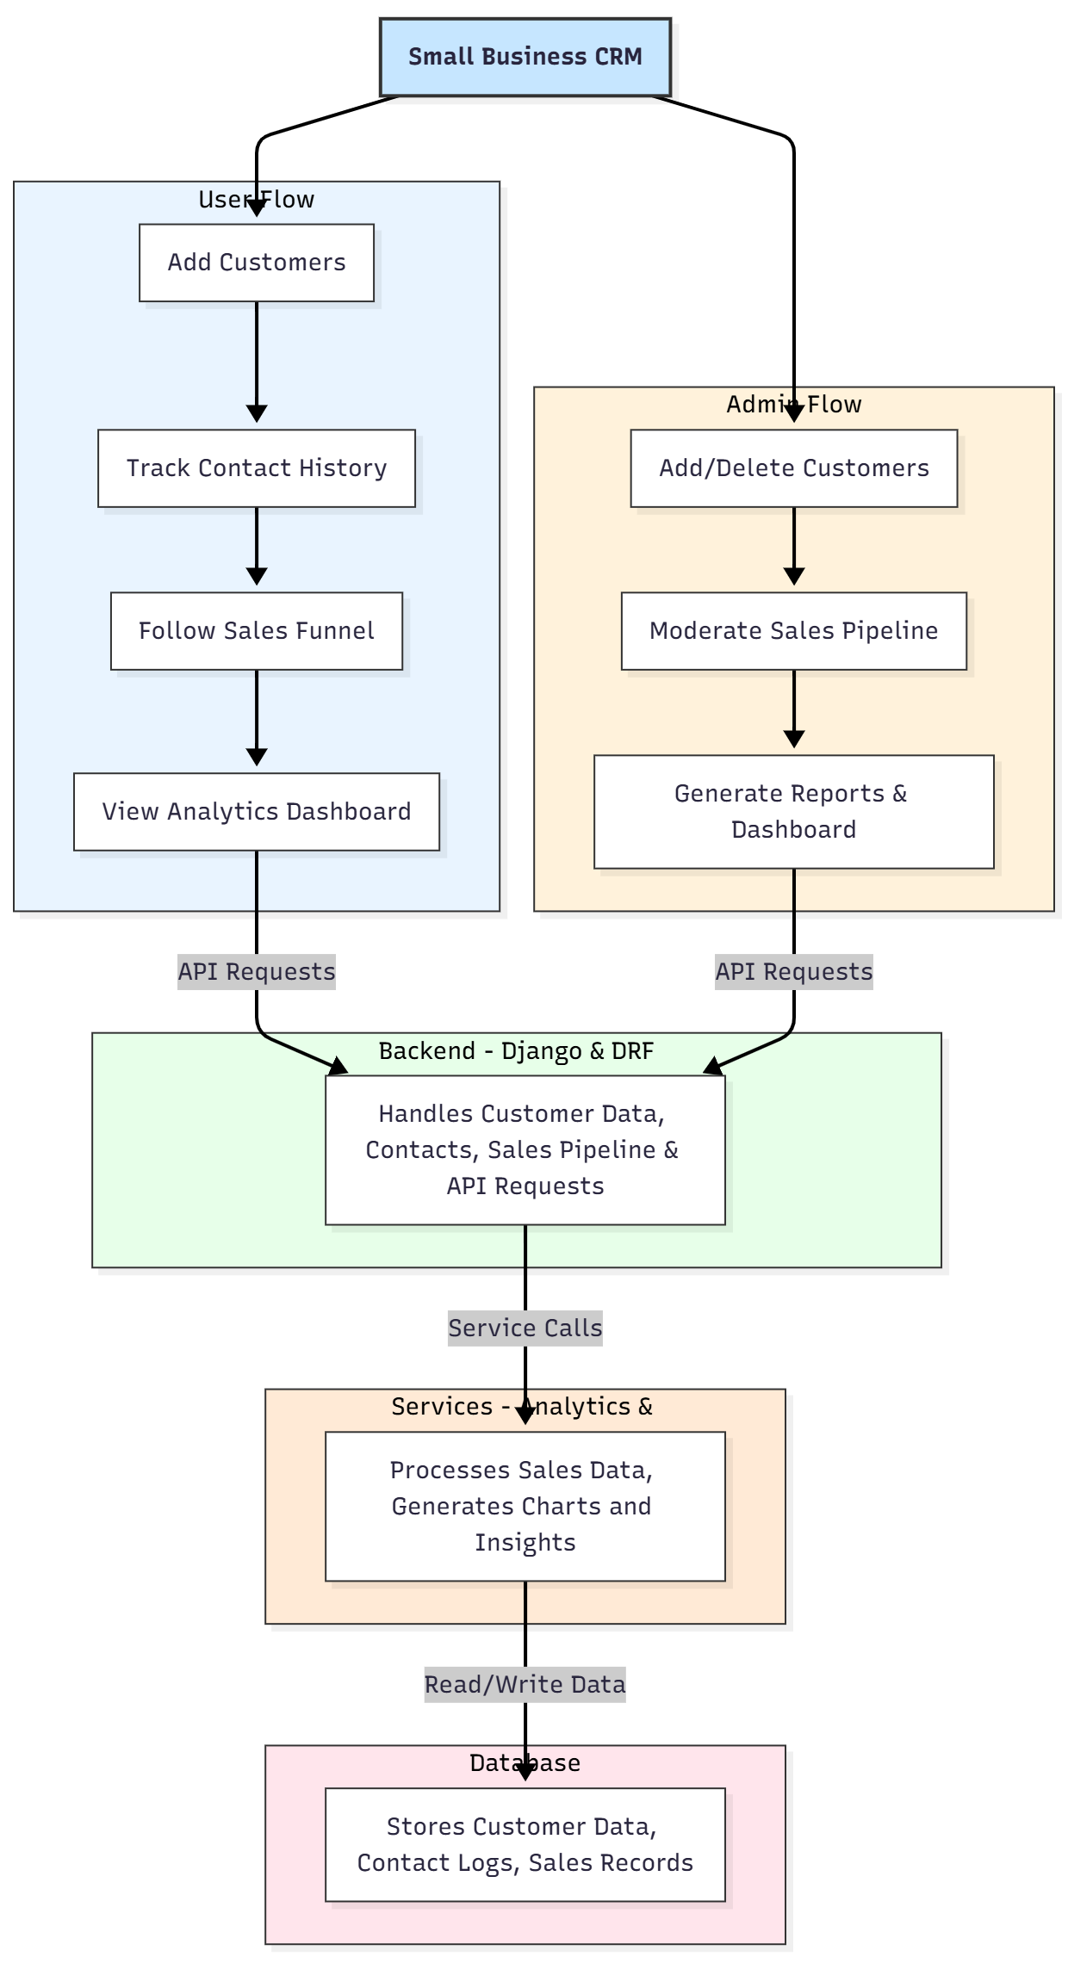

WORKING OF THE PROJECT:
Users begin by adding customer profiles with contact information and interaction history. They can track emails, phone calls, and meetings, as well as move leads through the sales funnel. The system logs all interactions in the backend database. Administrators monitor overall sales activities, moderate the pipeline, and generate reports and analytics dashboards. The backend handles API requests, ensures secure data storage, and processes analytics. Chart.js generates dynamic visualizations for performance metrics, providing actionable insights for sales improvement..

SOFTWARE REQUIREMENT:
- Backend:
  - Python 3.x
  - Django
  - Django REST Framework
  - SQLite/PostgreSQL
- Frontend:
  - Node.js and npm
  - React.js
  - Axios
- Development Tools:
  - Visual Studio Code
  - Postman (for testing APIs)
  - Git/GitHub (for version control)
- Server/Deployment (Optional):
  - Gunicorn, Nginx, or Heroku/AWS for hosting

ADVANTAGES OF THE PROJECT:

• Centralized customer management and interaction tracking
• Visual sales funnel for improved lead conversion
• Accurate record of emails, contacts, and sales activities
• Dashboard analytics for informed business decisions
• Administrative control over customer data and pipeline
• Reduces manual work and tracking errors
• Enhances productivity for freelancers, stores, and consultancies
• Scalable for growing businesses

APPLICATIONS OF THE PROJECT:
• Freelancers managing multiple clients
• Small retail stores for customer tracking
• Consultancies for client project follow-ups
• Service providers tracking customer engagement
• Any small business requiring sales and contact analytics

REFERENCES:

- Django REST Framework Documentation — Django Software Foundation. Django Documentation. Available: https://docs.djangoproject.com/
- Django REST Framework. DRF Documentation. Available: https://www.django-rest-framework.org/
- React. React Official Documentation. Available: https://reactjs.org/docs/getting-started.html
- Redux. Redux Documentation. Available: https://redux.js.org/introduction/getting-started
- PostgreSQL Global Development Group. PostgreSQL Documentation. Available: https://www.postgresql.org/docs/
- MySQL. MySQL Reference Manual. Available: https://dev.mysql.com/doc/
- Git. Git Documentation. Available: https://git-scm.com/doc
- Node.js. Node.js Documentation. Available: https://nodejs.org/en/docs/
- Axios. Axios Documentation. Available: https://axios-http.com/docs/intro
- Socket.io Documentation – https://socket.io/docs/

